Name |  | Max height | Table size | Load |  | Qty
SS cover scissor lift table |  | 1000mm | 1300*850 | 1000kg | STAINLESS COVER ON TOP | 1 set
Stainless Steel Scissors Table Lift (Picture is for reference)
1. Main structure of the Scissors: 80*40*3mm stainless steel tube
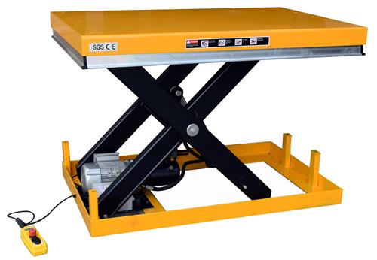
2. Lowered height: 205mm.
3. Working pressure: 10Mpa
4. Surface board: 6mm steel plate, with 304 SS cover.
5. Pump station: Germany
6. Power: 1.5Kw.
7. Electrical parts: Schneider Brand
8. O-Ring: Valqua, Japan
9. Package: Standard export wooden package.
10. Bearing: SF-1 auto-lubricating bearing without lube.
11. Control mode: Electric control by control cabinet and hand control panel.
12. Cylinder: Wearable fine cylinder with double O-ring,

13. Hydraulic oil pipe: High pressure double steel net rubber pipe
14. Hydraulic oil: Wearable hydraulic oil for air flight, The Grate Wall brand.
Note: The whole lift is made of 304 stainless steel except hydraulic cylinders.
With safety bars in case crashing something during lowering.
Our workshop pictures



